HW 3

Question 1: Find the value of c that minimizes: 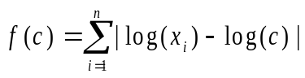
a. first derive: d[E|logxi-logc|]=E|log(xi)-(1/c)|=|logN(xi)-(n/c)|;
b. set =0: |log(N(xi)|=|(n/c)|
c. isolate c: c=|n/log[N(xi)]|=vertex.
Question 2: Find the values of 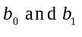that maximizes: 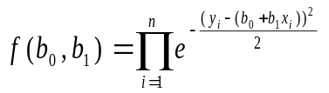
a. I notice that (y-(b0+b1xi))^2=(y-(b0+b1xi))(y-(b0+b1xi))=(y^2)+(b0^2)+((b1xi)^2)-2(b0b1xi)(y+1)=p.
b. Ne^-g=e^[(-1/2)E(p)]: lnf= [(-1/2)[E(y^2)+E(b0^2)+E(b1xi)^2-2E(b0b1xi)(y-1)]]=k
c. dk/db0=[(-1/2)[E(y^2)+2E(b0)+E(b1xi)^2-2E(b1xi)(y-1)]]=0
dk/db1=[(-1/2)[E(y^2)+E(b0^2)+2E(b1)(xi^2)-2E(b0xi)(y-1)]]=0 ((-1/2) is redundant)
d. 2E(b0)=-[E(y^2)+E(b1xi)^2-2E(b1xi)(y-1)]:2E(b1)(xi^2)=-[E(y^2)+E(b0^2)-2E(b0xi)(y-1)]
b0=-[(y^2)+(b1xi)^2-2(b1xi)(y-1)]/2 : b1=-[(y^2)+(b0^2)-2(b0xi)(y-1)]/2(xi^2).
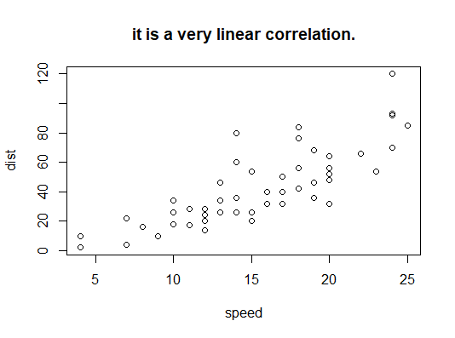
Question 3: Open the cars data set in R and answer the following questions. The code below will get you started: >install.packages(“datasets”) >library(datasets) >attach(cars) >carsA) Produce a scatterplot of the data, putting “speed” on the horizontal axis and “dist” on the vertical axis. Describe the relationship between the two variables. plot(speed,dist)

B) Find the correlation between the two variables and interpret this measure.
[1] 109.9469 Positive, very strong correlation.

C) Fit the linear regression using speed as the independent variable and distance as the dependent variable and report the regression equation. Use the equation to predict the stopping distance of a car traveling 23 MPH.
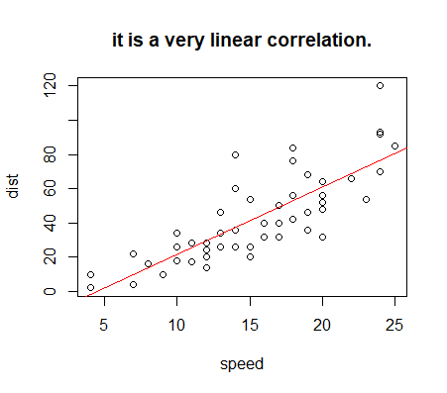
> lin.reg=lm(dist~speed)> lin.reg

Call:
lm(formula = dist ~ speed)

Coefficients:
(Intercept) speed
-17.579 3.932

> abline(lm(dist~speed),col="red")

=3.932x-17.579: 3.932(23)-17.579=72.857

D)Fit the quadratic regression using speed as the independent variable and distance as the dependent variable and report the regression equation. Use the equation to predict the stopping distance of a car traveling 30 MPH.
> fit.3=lm(dist~speed+I(speed^2))
> fit.3

Call:
lm(formula = dist ~ speed + I(speed^2))

Coefficients:
(Intercept) speed
2.47014 0.91329
I(speed^2)
0.09996
.09996(900)+.91329(30)+2.4014= 119.7641
> curve(.09996*x^2+.91329*x+2.47014.add=T,col="black")
Error: unexpected symbol in "curve(.09996*x^2+.91329*x+2.47014.add"
> curve(.09996*x^2+0.91329*x+2.47014.add=T,col="black")
Error: unexpected symbol in "curve(.09996*x^2+0.91329*x+2.47014.add"
> curve(.09996*x^2+.91329*x+2.47014,add=T,col="black")
> summary(fit.3)$r.squared
[1] 0.6673308
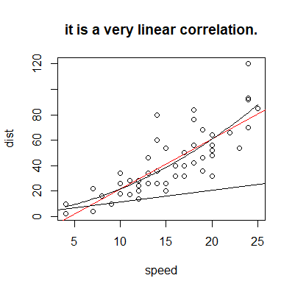

E)_Report the R² of the models in part C and part D. Which model fits the best in terms of R² ?
I think that the R^2 model fits better, but there is still a lot of error.
Question 4: Open the mtcars data set in R and answer the following questions. The code below will get you started along with a description of the variables: >dettach(cars) >attach(mtcars)
mpg Miles/(US) gallon
cyl Number of cylinders
disp Displacement (cu.in.)
hp Gross horsepower
drat Rear axle ratio
wt Weight (lb/1000)
qsec 1/4 mile time
vs V/S
am Transmission (0 = automatic, 1 = manual)
gear Number of forward gears
carb Number of carburetors
A) Fit the simple linear regression using wt as the independent variable and mpg as the dependent variable and report the regression equation. Use the equation to predict the mpg of a car having wt equal to 3.0 .
-5.344(3)+37.285=21.253

B) Fit the multiple linear regression using wt and hp as the independent variables and mpg as the dependent variable and report the regression equation. Use the equation to predict the mpg of a car having wt equal to 3.0 and hp equal to 100.
> lin.reg=(lm(mpg~wt+hp))
> plot(mpg,wt+hp)
> lin.reg

Call:
lm(formula = mpg ~ wt + hp)

Coefficients:
(Intercept) wt hp
37.22727 -3.87783 -0.03177
37.22727-3.177-3(3.87783)=22.41678
C) Fit the multiple linear regression using wt, hp, and qsec as the independent variables and mpg as the dependent variable and report the regression equation. Use the equation to predict the mpg of a car having wt equal to 3.0, hp equal to 100, and qsec equal to 18.
> lin.reg=(lm(mpg~wt+hp+qsec))
> lin.reg

Call:
lm(formula = mpg ~ wt + hp + qsec)

Coefficients:
(Intercept) wt hp qsec
27.61053 -4.35880 -0.01782 0.51083
27.61053-3(4.35880)-1.782+18(.51083)=21.94707
D) Fit the multiple linear regression using wt, hp, qsec, and cyl as the independent variables and mpg as the dependent variable and report the regression equation. Use the equation to predict the mpg of a car having wt equal to 3.0, hp equal to 100, qsec equal to 18, and cyl equal to 6.
> lin.reg=(lm(mpg~wt+hp+qsec+cyl))
> lin.reg

Call:
lm(formula = mpg ~ wt + hp + qsec + cyl)

Coefficients:
(Intercept) wt hp qsec cyl
34.28084 -3.47938 -0.01378 0.22616 -0.80986
34.28084-3(3.47938)-1.378+18(.22616)-6(.80986)=21.67642
